Create database
use shaiksushma1nt20is411

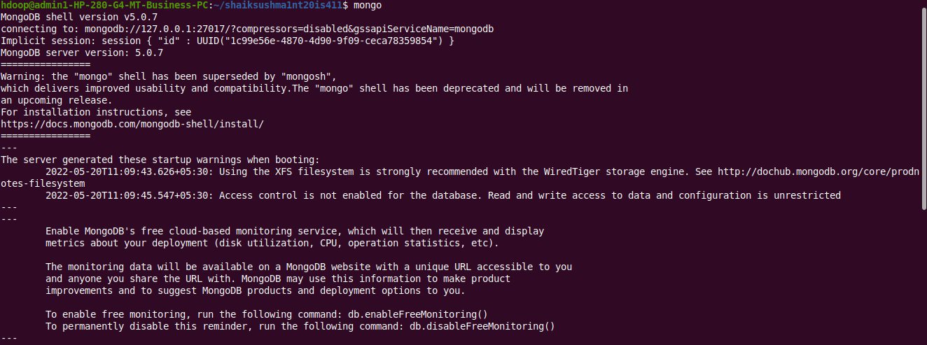
show dbs:
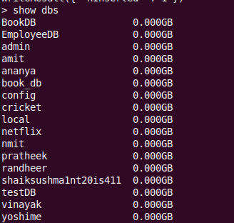

* insert one command and insert many command:
db.shaiksushma1nt20is411.insertOne({Name:"sushma",USN:"1nt20is411",dept:"ISE"})
{
"acknowledged" : true,
"insertedId" : ObjectId("628753421703437b6be249fe")
}
* insert many:
> db.shaiksushma1nt20is411.insertMany([{Name:"shaik",USN:"1in20is412",dept:"ISE"},
... {Name:"ram",USN:"1nt20is413",dept:"ISE"},{Name:"ravi",USN:"1nt20is414",dept:"ISE"}])
{
"acknowledged" : true,
"insertedIds" : [
ObjectId("6287541b1703437b6be249ff"),
ObjectId("6287541b1703437b6be24a00"),
ObjectId("6287541b1703437b6be24a01")
]
}
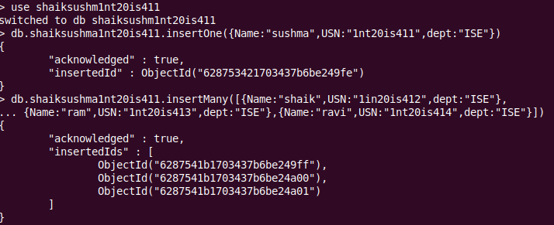
output of insert:
output using pretty command:
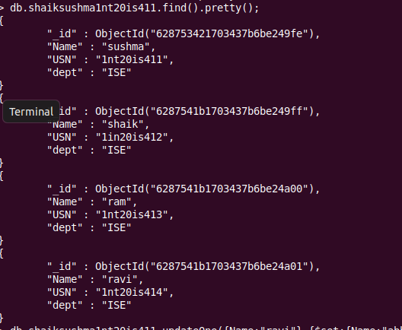

* update one and update many command:
db.shaiksushma1nt20is411.updateOne({Name:"ravi"},{$set:{Name:"abhi"}})
{ "acknowledged" : true, "matchedCount" : 1, "modifiedCount" : 1 }

> db.shaiksushma1nt20is411.find()
{ "_id" : ObjectId("628753421703437b6be249fe"), "Name" : "sushma", "USN" : "1nt20is411", "dept" : "ISE" }
{ "_id" : ObjectId("6287541b1703437b6be249ff"), "Name" : "shaik", "USN" : "1in20is412", "dept" : "ISE" }
{ "_id" : ObjectId("6287541b1703437b6be24a00"), "Name" : "ram", "USN" : "1nt20is413", "dept" : "ISE" }
{ "_id" : ObjectId("6287541b1703437b6be24a01"), "Name" : "abhi", "USN" : "1nt20is414", "dept" : "ISE" }

output :
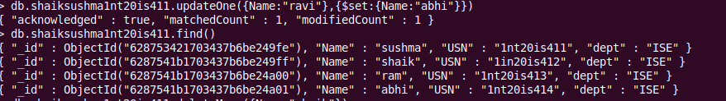
* delete command:
> db.shaiksushma1nt20is411.deleteMany({Name:"shaik"})
{ "acknowledged" : true, "deletedCount" : 1 }

output:
> db.shaiksushma1nt20is411.find()
{ "_id" : ObjectId("628753421703437b6be249fe"), "Name" : "sushma", "USN" : "1nt20is411", "dept" : "ISE" }
{ "_id" : ObjectId("6287541b1703437b6be24a00"), "Name" : "ram", "USN" : "1nt20is413", "dept" : "ISE" }
{ "_id" : ObjectId("6287541b1703437b6be24a01"), "Name" : "abhi", "USN" : "1nt20is414", "dept" : "ISE" }
>
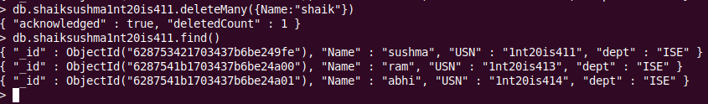
* set function in update:

db.shaiksushma1nt20is411.updateOne({Name:"sushma"},{$unset:{Name:""}})
{ "acknowledged" : true, "matchedCount" : 1, "modifiedCount" : 1 }
>
output:

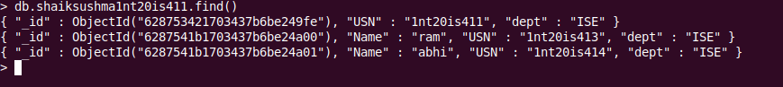
* ANDoperation:

db.shaiksushma1nt20is411.find({$and:[{"dept":"ISE"}]}).pretty()

* OR operation:
db.shaiksushma1nt20is411.find({$or:[{Name:"sheela"},{dept:"cse"}]}).pretty()

